Mindful Momentum

Software Requirements Specification

21-04-24

Divyam Verma

Prepared for

Continuous Assessment 3

Spring 2024

# 

# Revision History

|  |  |  |  |
| --- | --- | --- | --- |
| **Date** | **Description** | **Author** | **Comments** |
| 20-03-24 | The base html (home page) | Divyam Verma | Click getting started |
| 25-03-24 | Login/signup | Divyam Verma | Created two more pages |
| 05-04-24 | Books, quotes and articles | Divyam Verma | Completed front end |
| 20-04-24 | Attached mongoose and express | Divyam Verma | Completed back-end |

**Table of Contents**

Revision History ii

CLIENT Approval ii

1. Introduction 1

1.1 Purpose 1

1.2 Scope 1

1.3 Definitions, Acronyms, and Abbreviations 1

1.4 References 1

1.5 Overview 1

2. General Description 2

2.1 Product Perspective 2

2.2 Product Functions 2

2.3 User Characteristics 2

2.4 General Constraints 2

2.5 Assumptions and Dependencies 2

3. Specific Requirements 2

3.1 External Interface Requirements 3

3.1.1 User Interfaces 3

3.1.2 Hardware Interfaces 3

3.1.3 Software Interfaces 3

3.1.4 Communications Interfaces 3

3.2 Functional Requirements 3

3.2.1 <Functional Requirement or Feature #1> 3

3.2.2 <Functional Requirement or Feature #2> 3

3.5 Non-Functional Requirements 4

3.5.1 Performance 4

3.5.2 Reliability 4

3.5.3 Availability 4

3.5.4 Security 4

3.5.5 Maintainability 4

3.5.6 Portability 4

3.7 Design Constraints 4

3.9 Other Requirements 4

4. Analysis Models 4

4.1 Data Flow Diagrams (DFD) 5

5. Github link…………………………………………………………………………………………………….5

***1. Introduction***

* 1. *Purpose*

*The purpose of this report is to provide a comprehensive overview of the Mindful Momentum project, including its objectives, functionalities, requirements, and analysis models.*

* 1. *Scope*

*The scope of this report covers the development and features of the Mindful Momentum counselling website. It includes details about the technologies used, user interface design, functionality, and performance requirements.*

*1.3 Definitions, Acronyms, and Abbreviations*

*HTML: Hypertext Markup Language*

*CSS: Cascading Style Sheets*

*JavaScript: Programming language used for web development*

*Node.js: JavaScript runtime environment*

*DFD: Data Flow Diagram*

*GitHub: Web-based platform for version control and collaboration*

*UI: User Interface*

* 1. *References*

1. [Manastha - Best Online Counselling & Therapy | Best Online Psychologist Consultation India](https://www.manastha.com/)

*1.5 Overview*

*The Mindful Momentum project is a counselling website aimed at promoting personal growth, mindfulness, and self-improvement. It features a user-friendly interface, curated content, and interactive modules to enhance user experience and engagement. (2) Explain how the SRS is organized.*

**2. General Description**

**2.1 Product Perspective**

Mindful Momentum is positioned as a holistic platform for individuals seeking guidance, motivation, and resources for personal development. It is designed to be user-centric, providing a seamless and immersive experience for users.

**2.2 Product Functions**

The primary functions of Mindful Momentum include:

* Providing access to articles and resources on self-improvement and mindfulness.
* Offering a login/sign-up feature for personalized user experiences.
* Displaying motivational quotes and book recommendations for inspiration.
* Ensuring a responsive and visually appealing user interface.

**2.3 User Characteristics**

The target users of Mindful Momentum are individuals interested in personal growth, mindfulness practices, and self-discovery. The platform caters to users of various ages and backgrounds who seek tools and guidance for positive life changes.

**2.4 General Constraints**

Constraints for the project include:

* Compatibility with modern web browsers and devices.
* Adherence to accessibility standards for inclusive user experience.
* Compliance with data protection and privacy regulations.

**2.5 Assumptions and Dependencies**

Assumptions and dependencies for the project include:

* Availability of internet connectivity for user access.
* Integration with external APIs or services for certain functionalities (e.g., book recommendations).

**3. Specific Requirements**

**3.1 External Interface Requirements**

* **User Interfaces:** The website should have a user-friendly interface with clear navigation and interactive elements.
* **Hardware Interfaces:** Compatibility with standard web browsers and devices (desktop, mobile, tablets).
* **Software Interfaces:** Integration with backend services for user authentication, data storage, and content management.
* **Communications Interfaces:** Secure communication protocols for data transfer between client and server.

**3.2 Functional Requirements**

* **Login/Sign-up Functionality:** Users should be able to create accounts, log in, and access personalized features.
* **Navigation Features:** Intuitive navigation with menus, buttons, and links to different sections and content.

**3.5 Non-functional Requirements**

* **Performance:** Fast loading times, responsive design, and efficient server-side processing.
* **Reliability:** Stable and error-free operation under normal usage conditions.
* **Availability:** High availability to ensure users can access the website anytime.
* **Security:** Secure data transmission, authentication mechanisms, and protection against cyber threats.
* **Maintainability:** Easy to update and maintain, with clear documentation for developers.
* **Portability:** Compatibility across different devices and platforms.

**3.7 Design Constraints**

Design constraints include adhering to brand guidelines, ensuring consistency in visual elements, and optimizing for accessibility and usability standards.

**3.9 Other Requirements**

Any additional requirements specific to the project, such as performance benchmarks, scalability considerations, or integration with third-party services.

4- Level 1 DFD

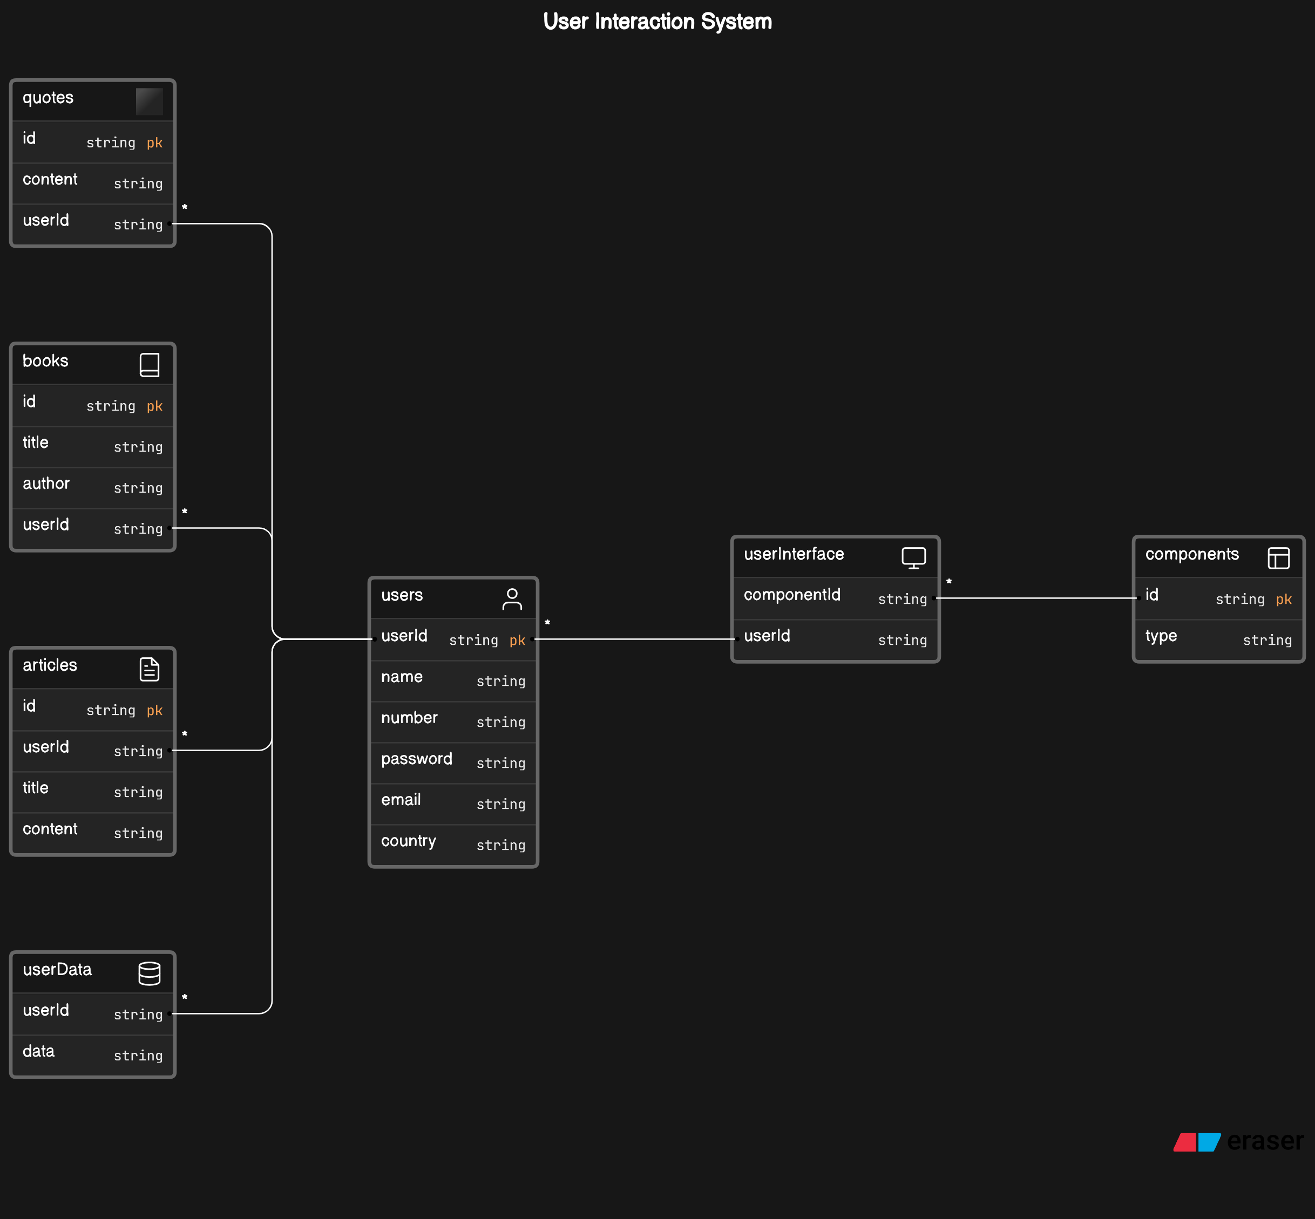

Github Link:

[divyamverma26/Ca3-project (github.com)](https://github.com/divyamverma26/Ca3-project)